**Features used for fitting a HMM model**

* MCQ.TOT.FACT: compute MCQ.TOT as EQT.CO + EQT.IN+VEQ.CO+VEQ.IN, then discretize it as follows: all instances with MCQ.TOT == 0 put in one group; instances with MCQ.TOT >= 1 split into quantiles; then, create a factor variable MCQ.TOT.FACT with 5 levels: one for instances with MCQ.TOT == 0, and 4 for the 4 quantile groups
* MCQ.PERC.CO.FACT: percentage of correctly solved MCQs; compute MCQ.PERC.CO as ((EQT.CO+VEQ.CO)/MCQ.TOT)*100; then discretize it into 5 level factor variable: one level for the situation when no MCQ was solved (no MCQs related activities) and the other 4 corresponding to the 4 quartiles of MCQ.PERC.CO
* EXC.TOT.FACT: compute EXC.TOT = EXC.CO + EXC.IN; then discretize analog to MCQ.TOT.FACT
* EXC.PERC.CO: compute (EXC.CO*100)/EXC.TOT, the discretize analog to MCQ.PERC.CO.FACT
* VID.TOT.FACT: compute VID.TOT = VID.PL + VID.PA, then discretize analog to MCQ.TOT.FACT
* MCQ.SH.TOT.FACT: compute MCQ.SH.TOT = EQT.SH + VEQ.SH, then analog to MCQ.TOT.FACT
* TG.DENS.FACT: transition graph density; discretized like the variables described above
* MC.EVAL.FACT: compute DBOARD.VIEW, then discretize analog to MCQ.TOT.FACT
* CONTENT.ACCESS.FACT: discretize analog to MCQ.TOT.FACT

**Examining HMM models with different numbers of states**

***nstates = 3***

> print(mod.fit)

Convergence info: Log likelihood converged to within tol. (relative change)

'log Lik.' -36670.05 (df=116)

AIC: 73572.09

BIC: 74282.8

***nstates = 4***

> print(mod.fit)

Convergence info: Log likelihood converged to within tol. (relative change)

'log Lik.' -35908.78 (df=159)

AIC: 72135.55 (drop: 1436)

BIC: 73109.72 (drop: 1173)

***nstates = 5***

> print(mod.fit)

Convergence info: Log likelihood converged to within tol. (relative change)

'log Lik.' -34800.35 (df=204)

AIC: 70008.71 (drop: 2127)

BIC: 71258.58 (drop: 1851)

***nstates = 6***

> print(mod.fit)

Convergence info: Log likelihood converged to within tol. (relative change)

'log Lik.' -34558.77 (df=251)

AIC: 69619.55 (drop: 389)

BIC: 71157.38 (drop: 101)

**Model with 5 states**

This model is chosen since the highest increase in log-likelihood and the largest drop in AIC and BIC values are present between the models with 4 and 5 states

**STATE 1 – Low active, focused on summative assessment**

MCQ.TOT.FACT

"0" "Q1" "Q2" "Q3" "Q4"

St1 1 0.00000000 0.0000000 0.0000000 0.00000000

MCQ.PERC.CO.FACT

"0" "Q1" "Q2" "Q3" "Q4"

St1 1.0000000000 0.0000000 0.0000000 0.0000000 0.0000000

EXC.TOT.FACT

"0" "Q1" "Q2" "Q3" "Q4"

St1 0.000000000 0.29321540 0.1833764 0.2293401 0.2940681

EXC.PERC.CO.FACT

"0" "Q1" "Q2" "Q3" "Q4"

St1 0.000000000 0.3495480 0.2808741 0.1942884 0.1752895

VID.TOT.FACT

"0" "Q1" "Q2" "Q3" "Q4"

St1 0.97297295 0.01842641 0.005885011 0.00000000 0.002715633

MCQ.SH.TOT.FACT

"0" "Q1" "Q2" "Q3" "Q4"

St1 1.0000000 0.0000000 0.0000000 0.0000000 0.00000000

TG.DENS.FACT

"0" "Q1" "Q2" "Q3" "Q4"

St1 0.027823470 0.36855095 0.58928000 0.01434559 0.000000000

MC.EVAL.FACT

"0" "Q1" "Q2" "Q3" "Q4"

St1 0.9212726 0.03286222 0.01795996 0.01871732 0.009187866

CONTENT.ACCESS.FACT

"0" "Q1" "Q2" "Q3" "Q4"

St1 6.097922e-01 0.26715807 0.07104687 0.03877506 0.01322781

**STATE 2 – Highly active, engaged in all activities**

MCQ.TOT.FACT

"0" "Q1" "Q2" "Q3" "Q4"

St2 0 0.06060883 0.2299928 0.3328387 0.37655966

MCQ.PERC.CO.FACT

"0" "Q1" "Q2" "Q3" "Q4"

St2 0.0004113408 0.2323335 0.2774395 0.2946904 0.1951253

EXC.TOT.FACT

"0" "Q1" "Q2" "Q3" "Q4"

St2 0.001069364 0.20005528 0.2761829 0.2808137 0.2418788

EXC.PERC.CO.FACT

"0" "Q1" "Q2" "Q3" "Q4"

St2 0.001069364 0.1557455 0.2461438 0.2849228 0.3121185

VID.TOT.FACT

"0" "Q1" "Q2" "Q3" "Q4"

St2 0.05485087 0.19090639 0.191948894 0.26387916 0.298414684

MCQ.SH.TOT.FACT

"0" "Q1" "Q2" "Q3" "Q4"

St2 0.2473511 0.1541016 0.1330341 0.2044147 0.26109851

TG.DENS.FACT

"0" "Q1" "Q2" "Q3" "Q4"

St2 0.004638276 0.00000000 0.03288267 0.26314299 0.699336070

MC.EVAL.FACT

"0" "Q1" "Q2" "Q3" "Q4"

St2 0.4449712 0.13932568 0.10894681 0.12841503 0.178341299

CONTENT.ACCESS.FACT

"0" "Q1" "Q2" "Q3" "Q4"

St2 5.909792e-04 0.07079815 0.19392918 0.29655398 0.43812771

**STATE 3 – Very low activity, focused on reading**

MCQ.TOT.FACT

"0" "Q1" "Q2" "Q3" "Q4"

St3 1 0.00000000 0.0000000 0.0000000 0.00000000

MCQ.PERC.CO.FACT

"0" "Q1" "Q2" "Q3" "Q4"

St3 1.0000000000 0.0000000 0.0000000 0.0000000 0.0000000

EXC.TOT.FACT

"0" "Q1" "Q2" "Q3" "Q4"

St3 0.956331878 0.04366812 0.0000000 0.0000000 0.0000000

EXC.PERC.CO.FACT

"0" "Q1" "Q2" "Q3" "Q4"

St3 1.000000000 0.0000000 0.0000000 0.0000000 0.0000000

VID.TOT.FACT

"0" "Q1" "Q2" "Q3" "Q4"

St3 0.93886463 0.03056769 0.008733624 0.01310044 0.008733624

MCQ.SH.TOT.FACT

"0" "Q1" "Q2" "Q3" "Q4"

St3 1.0000000 0.0000000 0.0000000 0.0000000 0.00000000

TG.DENS.FACT

"0" "Q1" "Q2" "Q3" "Q4"

St3 0.541484716 0.36244541 0.06986900 0.01746725 0.008733624

MC.EVAL.FACT

"0" "Q1" "Q2" "Q3" "Q4"

St3 0.9213974 0.02620087 0.03056769 0.01746725 0.004366812

CONTENT.ACCESS.FACT

"0" "Q1" "Q2" "Q3" "Q4"

St3 6.419214e-01 0.24454148 0.06113537 0.03493450 0.01746725

**STATE 4 – Moderately active, engaged in all activities**

MCQ.TOT.FACT

"0" "Q1" "Q2" "Q3" "Q4"

St4 0 0.51761169 0.2522891 0.1375650 0.09253425

MCQ.PERC.CO.FACT

"0" "Q1" "Q2" "Q3" "Q4"

St4 0.0442713410 0.2800706 0.1826882 0.1981913 0.2947786

EXC.TOT.FACT

"0" "Q1" "Q2" "Q3" "Q4"

St4 0.100024339 0.28523622 0.2348833 0.2174579 0.1623983

EXC.PERC.CO.FACT

"0" "Q1" "Q2" "Q3" "Q4"

St4 0.100024339 0.2143401 0.1960824 0.2407280 0.2488252

VID.TOT.FACT

"0" "Q1" "Q2" "Q3" "Q4"

St4 0.31254760 0.24100842 0.182004938 0.13676685 0.127672190

MCQ.SH.TOT.FACT

"0" "Q1" "Q2" "Q3" "Q4"

St4 0.2688395 0.3035321 0.2137388 0.1444279 0.06946177

TG.DENS.FACT

"0" "Q1" "Q2" "Q3" "Q4"

St4 0.055615566 0.15906056 0.39116002 0.33207129 0.062092566

MC.EVAL.FACT

"0" "Q1" "Q2" "Q3" "Q4"

St4 0.8186095 0.09178395 0.03808021 0.03674254 0.014783846

CONTENT.ACCESS.FACT

"0" "Q1" "Q2" "Q3" "Q4"

St4 1.677662e-01 0.27661908 0.25499825 0.19474209 0.10587438

**STATE 5 – Moderately active, focused on summative assessment and reading**

MCQ.TOT.FACT

"0" "Q1" "Q2" "Q3" "Q4"

St5 1 0.00000000 0.0000000 0.0000000 0.00000000

MCQ.PERC.CO.FACT

"0" "Q1" "Q2" "Q3" "Q4"

St5 1.0000000000 0.0000000 0.0000000 0.0000000 0.0000000

EXC.TOT.FACT

"0" "Q1" "Q2" "Q3" "Q4"

St5 0.000000000 0.21757163 0.2804535 0.2397925 0.2621823

EXC.PERC.CO.FACT

"0" "Q1" "Q2" "Q3" "Q4"

St5 0.000000000 0.3016142 0.2435728 0.2770035 0.1778095

VID.TOT.FACT

"0" "Q1" "Q2" "Q3" "Q4"

St5 0.45853260 0.21275455 0.148805305 0.09769945 0.082208095

MCQ.SH.TOT.FACT

"0" "Q1" "Q2" "Q3" "Q4"

St5 1.0000000 0.0000000 0.0000000 0.0000000 0.00000000

TG.DENS.FACT

"0" "Q1" "Q2" "Q3" "Q4"

St5 0.000000000 0.07106392 0.41204304 0.48758320 0.029309836

MC.EVAL.FACT

"0" "Q1" "Q2" "Q3" "Q4"

St5 0.7555285 0.12127842 0.05253319 0.04116760 0.029492339

CONTENT.ACCESS.FACT

"0" "Q1" "Q2" "Q3" "Q4"

St5 1.165603e-05 0.28224027 0.27530804 0.28223751 0.16020252

**Transition Matrix**

|  |  |  |  |  |  |
| --- | --- | --- | --- | --- | --- |
|  | Low active, focused on sum. assessment | Highly active, engaged in all activities | Very low activity / focused on reading | Moderately active, engaged in all activities | Moderately active, focused on sum. assess. and reading |
| Low active, focused on sum. assessment | **0.55** | 0.05 | 0.09 | 0.21 | 0.10 |
| Highly active, engaged in all activities | 0.06 | **0.65** | 0.02 | 0.18 | 0.08 |
| Very low activity, focused on reading | **0.30** | 0.09 | 0.24 | **0.30** | 0.07 |
| Moderately active, engaged in all activities | 0.21 | 0.25 | 0.07 | **0.34** | 0.13 |
| Moderately active, focused on sum. assess. and reading | 0.19 | 0.19 | 0.03 | **0.31** | **0.30** |

**Initial state probabilities**

pr1 pr2 pr3 pr4 pr5

0 0 1 0 0

The most probable initial state is *Very low activity, focused on reading*, which is probably expected.

**Number of students per week and per state**

Weeks are given in rows (W2-W13), states are given in columns (S1-S5); below is a figure with the same information presented using stacked barcharts.

=== === === === === ===

\ S1 S2 S3 S4 S5

=== === === === === ===

W2 22 104 40 91 15

W3 36 121 15 106 6

W4 53 122 14 73 22

W5 68 103 16 59 38

W6 16 122 10 134 5

W7 104 85 10 29 57

W8 123 74 11 32 46

W9 121 66 14 32 47

W10 92 55 48 39 41

W11 118 68 19 31 45

W12 101 66 21 26 65

W13 22 61 11 184 9

=== === === === === ===

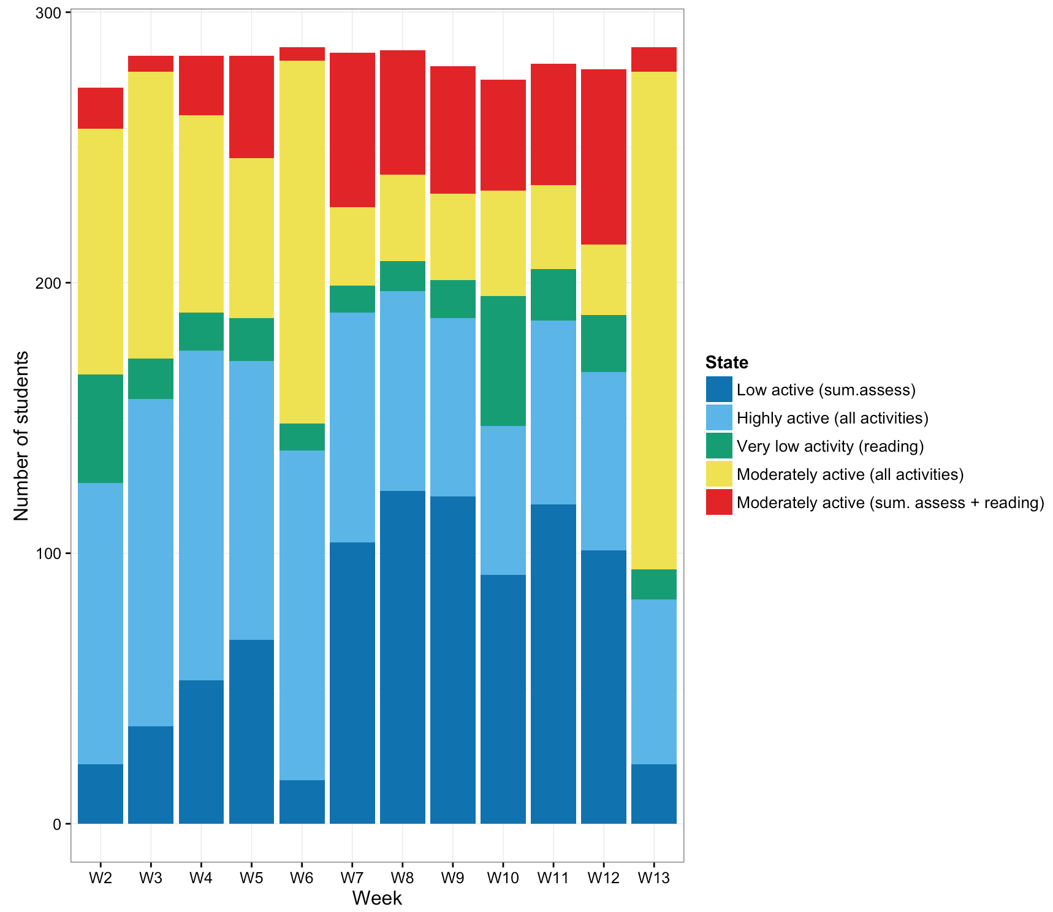

**Raw output**

> summary(mod.fit)

Initial state probabilties model

pr1 pr2 pr3 pr4 pr5

0 0 1 0 0

Transition matrix

toS1 toS2 toS3 toS4 toS5

fromS1 0.54833411 0.05456205 0.08676566 0.2125126 0.09782557

fromS2 0.06271279 0.65170133 0.02241667 0.1789140 0.08425516

fromS3 0.29869851 0.09410469 0.24017467 0.2989084 0.06811372

fromS4 0.20977721 0.25018967 0.07168081 0.3362741 0.13207820

fromS5 0.19137722 0.19521450 0.03457970 0.3094677 0.26936084

Response parameters

MCQ.TOT.FACT

"0" "Q1" "Q2" "Q3" "Q4"

St1 1 0.00000000 0.0000000 0.0000000 0.00000000

St2 0 0.06060883 0.2299928 0.3328387 0.37655966

St3 1 0.00000000 0.0000000 0.0000000 0.00000000

St4 0 0.51761169 0.2522891 0.1375650 0.09253425

St5 1 0.00000000 0.0000000 0.0000000 0.00000000

MCQ.PERC.CO.FACT

"0" "Q1" "Q2" "Q3" "Q4"

St1 1.0000000000 0.0000000 0.0000000 0.0000000 0.0000000

St2 0.0004113408 0.2323335 0.2774395 0.2946904 0.1951253

St3 1.0000000000 0.0000000 0.0000000 0.0000000 0.0000000

St4 0.0442713410 0.2800706 0.1826882 0.1981913 0.2947786

St5 1.0000000000 0.0000000 0.0000000 0.0000000 0.0000000

EXC.TOT.FACT

"0" "Q1" "Q2" "Q3" "Q4"

St1 0.000000000 0.29321540 0.1833764 0.2293401 0.2940681

St2 0.001069364 0.20005528 0.2761829 0.2808137 0.2418788

St3 0.956331878 0.04366812 0.0000000 0.0000000 0.0000000

St4 0.100024339 0.28523622 0.2348833 0.2174579 0.1623983

St5 0.000000000 0.21757163 0.2804535 0.2397925 0.2621823

EXC.PERC.CO.FACT

"0" "Q1" "Q2" "Q3" "Q4"

St1 0.000000000 0.3495480 0.2808741 0.1942884 0.1752895

St2 0.001069364 0.1557455 0.2461438 0.2849228 0.3121185

St3 1.000000000 0.0000000 0.0000000 0.0000000 0.0000000

St4 0.100024339 0.2143401 0.1960824 0.2407280 0.2488252

St5 0.000000000 0.3016142 0.2435728 0.2770035 0.1778095

VID.TOT.FACT

"0" "Q1" "Q2" "Q3" "Q4"

St1 0.97297295 0.01842641 0.005885011 0.00000000 0.002715633

St2 0.05485087 0.19090639 0.191948894 0.26387916 0.298414684

St3 0.93886463 0.03056769 0.008733624 0.01310044 0.008733624

St4 0.31254760 0.24100842 0.182004938 0.13676685 0.127672190

St5 0.45853260 0.21275455 0.148805305 0.09769945 0.082208095

MCQ.SH.TOT.FACT

"0" "Q1" "Q2" "Q3" "Q4"

St1 1.0000000 0.0000000 0.0000000 0.0000000 0.00000000

St2 0.2473511 0.1541016 0.1330341 0.2044147 0.26109851

St3 1.0000000 0.0000000 0.0000000 0.0000000 0.00000000

St4 0.2688395 0.3035321 0.2137388 0.1444279 0.06946177

St5 1.0000000 0.0000000 0.0000000 0.0000000 0.00000000

TG.DENS.FACT

"0" "Q1" "Q2" "Q3" "Q4"

St1 0.027823470 0.36855095 0.58928000 0.01434559 0.000000000

St2 0.004638276 0.00000000 0.03288267 0.26314299 0.699336070

St3 0.541484716 0.36244541 0.06986900 0.01746725 0.008733624

St4 0.055615566 0.15906056 0.39116002 0.33207129 0.062092566

St5 0.000000000 0.07106392 0.41204304 0.48758320 0.029309836

MC.EVAL.FACT

"0" "Q1" "Q2" "Q3" "Q4"

St1 0.9212726 0.03286222 0.01795996 0.01871732 0.009187866

St2 0.4449712 0.13932568 0.10894681 0.12841503 0.178341299

St3 0.9213974 0.02620087 0.03056769 0.01746725 0.004366812

St4 0.8186095 0.09178395 0.03808021 0.03674254 0.014783846

St5 0.7555285 0.12127842 0.05253319 0.04116760 0.029492339

CONTENT.ACCESS.FACT

"0" "Q1" "Q2" "Q3" "Q4"

St1 6.097922e-01 0.26715807 0.07104687 0.03877506 0.01322781

St2 5.909792e-04 0.07079815 0.19392918 0.29655398 0.43812771

St3 6.419214e-01 0.24454148 0.06113537 0.03493450 0.01746725

St4 1.677662e-01 0.27661908 0.25499825 0.19474209 0.10587438

St5 1.165603e-05 0.28224027 0.27530804 0.28223751 0.16020252